Use Cases Description
UC1- Account Management

For

Meeting Room
Booking System
(MRBS)

Prepared by K15T1-Team11
Van Lang University
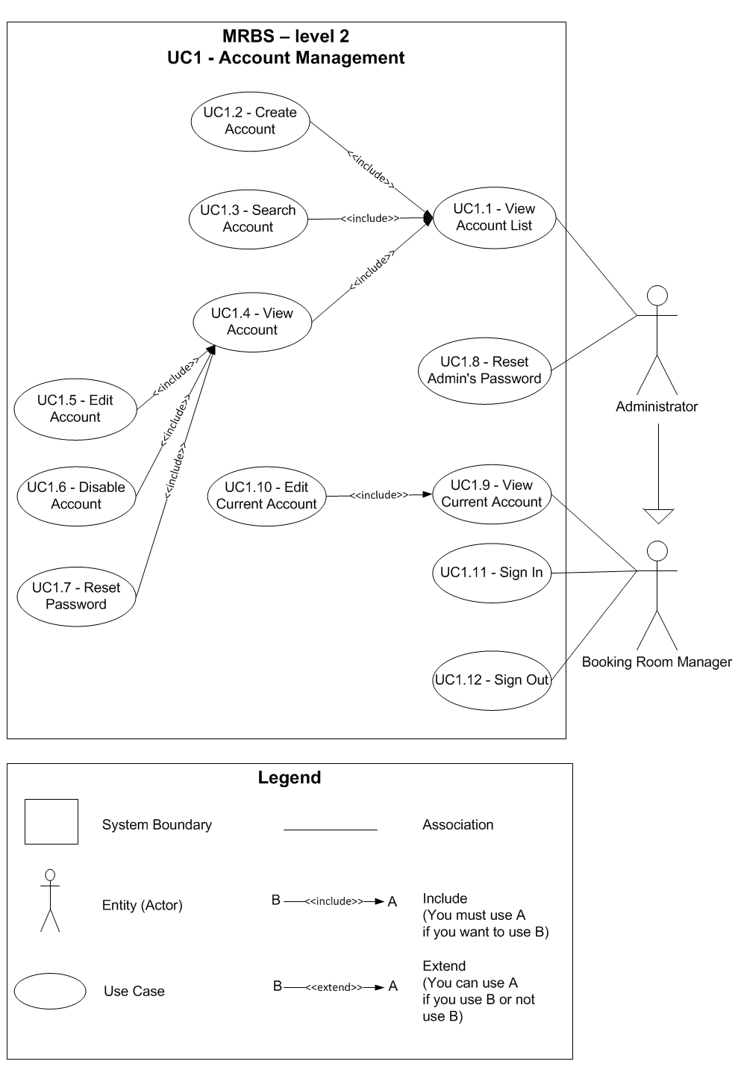
Table of Contents
UC1.1 – View Account List 4
UC1.2 – Create Account 4
UC1.3 – Search Account 5
UC1.4 – View Account 6
UC1.5 – Edit Account 7
UC1.6 – Disable Account 8
UC1.7 – Reset Password 8
UC1.8 – Reset Admin’s Password 9
UC1.9 – View Current User 10
UC1.10 – Edit Current User 10
UC1.11 – Sign In 12
UC1.12 – Sign Out 13

UC1.1 – View Account List
ID | UC1.1
Name | View Account List
Author | Son Dang | Modify by | Tam Do
Date | 06/18/12 | Update | 06/29/12
Actor | Administrator
Description | User can view list of account
Precondition | User signed in system by Administrator’s account
Post condition: | System shows all account
Main flow: | 1. User press “Danh mục”  2. User choose “Quản lý tài khoản”  3. System show new dialog “Quản lý tài khoản”  4. System show a list of account
Alternative flow:
Exception :
Includes:
Priority: | Normal
Business rules:
Mockup screen

UC1.2 – Create Account
ID | UC1.2
Name | Create Account
Author | Son Dang | Modify by | Tam Do
Date | 06/18/12 | Update | 07/08/12
Actor | Administrator
Description | User can create a new account
Precondition | User signed in system by Booking Room Manager’s account  User staying at “Quản lý tài khoản” form
Post condition: | System create a new account into database
Main flow: | 1. User press “Thêm mới” button  2. System change form to create a new account  3. User fill in the form  4. User press “Lưu” button  5. System check the valid of information (BR1.2.01, BR1.2.02, BR1.2.03; BR1.2.04; BR1.2.05)  6. System check the valid of information with existing data in database (BR1.2.06, BR1.2.07)  7. System save a new room into database  8. System show message that “Thêm phòng thành công” with “OK” button
Alternative flow: | After step 3 of main flow:  4. User press “Hủy” button  5. System change form to not create a new room
Alternative flow: | After step 5 of main flow (BR1.2.01):  6. System show message that “Các thông tin có (*) không được để trống” with “OK” button
Alternative flow: | After step 5 of main flow (BR1.2.02, BR1.2.03; BR1.2.04; BR1.2.05):  6. System show message that “Thông tin nhập vào không hợp lệ” with “OK” button
Alternative flow: | After step 6 of main flow (BR1.2.06, BR1.2.07):  7. System show message that “Tên tài khoản hoặc Email đã tồn tại trong hệ thống, vui lòng thử lại” with “OK” button
Exception :
Includes:
Priority: | High
Business rules: | BR1.2.01 – Required field not accept null: “Tên tài khoản”; “Họ tên”; “Email”  BR1.2.02 – “Tên tài khoản” not accept space between them; accept alphanumeric only  BR1.2.03 – “Họ tên” accept alphanumeric, can use Vietnamese language  BR1.2.04 – “Số diện thoại” accept numeric only  BR1.2.05 – “Email” not accept space between them; accept alphanumeric, "@" and "." only  BR1.2.06 – “Tên tài khoản” not exist in database  BR1.2.07 – “Email” not exist in database
Mockup screen

UC1.3 – Search Account
ID | UC1.3
Name | Search Account
Author | Son Dang | Modify by | Tam Do
Date | 06/18/12 | Update | 07/12/12
Actor | Administrator
Description | User can search account by name, account name or view all account
Precondition | User signed in system by Booking Room Manager’s account  User staying at “Quản lý tài khoản” form
Post condition: | System show the results
Main flow: | 1. User types the word to search for name or account name  2. User press “Enter” from the keyboard  3. System check the valid of information (BR1.3.01)  4. System show the results
Alternative flow: | After step 4 of main flow:  5. User press “Tất cả” button  6. System show all room on list of room
Exception :
Includes:
Priority: | Normal
Business rules: | BR1.3.01 – “Tìm kiếm phòng” accept alphanumeric only
Mockup screen

UC1.4 – View Account
ID | UC1.4
Name | View Account
Author | Son Dang | Modify by | Tam Do
Date | 06/18/12 | Update | 06/29/12
Actor | Administrator
Description | User can view a detail account information
Precondition | User signed in system by Booking Room Manager’s account  User staying at “Quản lý tài khoản” form
Post condition: | System show a detail account information that user choose
Main flow: | 1. User choose an account from list of account  2. System show a detail account information that user choose
Alternative flow:
Exception :
Includes:
Priority: | Normal
Business rules:
Mockup screen

UC1.5 – Edit Account
ID | UC1.5
Name | Edit Account
Author | Son Dang | Modify by | Tam Do
Date | 06/18/12 | Update | 07/12/12
Actor | Administrator
Description | User can edit an account information
Precondition | User signed in system by Booking Room Manager’s account  User staying at “Quản lý tài khoản” form and viewing a detail account information
Post condition: | System edit an account information in database
Main flow: | 1. User edit a room information that accept to edit (BR1.5.01)  2. User press “Lưu” button  3. System check the valid of information (BR1.5.02)  4. System save a room information that edited in database  5. System show message that “Chỉnh sửa thông tin thành công” with “OK” button
Alternative flow: | After step 3 of main flow:  4. User press “Hủy” button  5. System change form to not create a new room
Alternative flow: | After step 5 of main flow (BR1.5.01):  6. System show message that “Các thông tin có (*) không được để trống” with “OK” button
Alternative flow: | After step 5 of main flow (BR1.5.02; BR1.5.03; BR1.5.04):  6. System show message that “Thông tin nhập vào không hợp lệ” with “OK” button
Alternative flow: | After step 6 of main flow (BR1.5.05):  7. System show message that “Email đã tồn tại trong hệ thống, vui lòng thử lại” with “OK” button
Exception :
Includes:
Priority:
Business rules: | High
Mockup screen | BR1.5.01 – Required field not accept null: “Họ tên”; “Email”  BR1.5.02 – “Họ tên” accept alphanumeric, can use Vietnamese language  BR1.5.03 – “Số diện thoại” accept numeric only  BR1.5.04 – “Email” not accept space between them; accept alphanumeric, "@" and "." only  BR1.5.05 – “Email” not exist in database

UC1.6 – Disable Account
ID | UC1.6
Name | Disable Account
Author | Son Dang | Modify by | Tam Do
Date | 06/18/12 | Update | 07/20/12
Actor | Administrator
Description | User can disable an account information
Precondition | User signed in system by Booking Room Manager’s account  User staying at “Quản lý tài khoản” form and viewing a detail account information
Post condition: | System disable an account information in database
Main flow: | 1. User press “Xóa” button  2. System show message that “Bạn có muốn xóa thông tin này khỏi hệ thống không?” with “Yes” and “No” button  3. User press “Yes” button  4. System disable an account information in database
Alternative flow: | After step 2 of main flow:  3. User press “No” button  4. Nothing appears
Exception :
Includes:
Priority: | Normal
Business rules:
Mockup screen

UC1.7 – Reset Password
ID | UC1.7
Name | Reset Account
Author | Tam Do | Modify by
Date | 06/29/12 | Update
Actor | Administrator
Description | User can reset password for other accounts
Precondition | User signed in system by Booking Room Manager’s account  User staying at “Quản lý tài khoản” form and viewing a detail account information
Post condition: | System reset password into default password (same as account name) and save into database
Main flow: | 1. User press “Reset MK” button  2. System reset password and save into database  3. System show message that “Mật khẩu đã được reset thành công” với “OK” button
Alternative flow:
Exception :
Includes:
Priority: | Normal
Business rules:
Mockup screen

UC1.8 – Reset Admin’s Password
ID | UC1.8
Name | Reset Admin’s Password
Author | Tam Do | Modify by | Tam Do
Date | 06/29/12 | Update | 07/12/12
Actor | Administrator
Description | User can reset Administrator’s password
Precondition | User cannot sign in system by Administrator’s account  User at Sign In form
Post condition: | System reset Administrator’s password and save into database
Main flow: | 1. User press “Reset mật khẩu Admin?” link  2. User enter password level 2  3. User press “Reset” button  4. System check password level 2 (BR1.8.01)  5. System save into database  6. System show message that “Mật khẩu admin đã được reset thành công” with “OK” button
Alternative flow: | After step 4 of main flow (BR1.8.01):  5. System show message that “Mật khẩu 2 không đúng. Vui lòng thử lại”
Exception :
Includes:
Priority: | Very High
Business rules: | BR1.8.01 – “Mật khẩu 2” must correct with password level 2 in database
Mockup screen

UC1.9 – View Current User
ID | UC1.9
Name | View Current User
Author | Tam Do | Modify by
Date | 06/29/12 | Update
Actor | Administrator, Booking Room Manager
Description | User can view current account
Precondition | User signed in system
Post condition: | System show current account information
Main flow: | 1. User press “Account name” button  2. System show current account information
Alternative flow:
Exception :
Includes:
Priority: | Normal
Business rules:
Mockup screen

UC1.10 – Edit Current User
ID | UC1.10
Name | Edit Current User
Author | Son Dang | Modify by | Tam Do
Date | 06/18/12 | Update | 07/12/12
Actor | Administrator, Booking Room Manager
Description | User can change password of current user account
Precondition | User signed in system by Booking Room Manager’s account  User viewing a current user account
Post condition: | System save into database
Main flow: | 1. User press “Đổi mật khẩu” button  2. User fill in the form  3. User press “Đồng ý” button  4. System check the valid of information (BR1.10.01; BR1.10.02; BR1.10.03; BR1.10.04; BR1.10.05; BR1.10.06)  5. System check the valid of information with existing data in database (BR1.10.07)  6. System save a password into database  7. System show message that “Đổi mật khẩu người dùng thành công” with “OK” button
Alternative flow: | After step 2 of main flow:  3. User press “Hủy” button  4. System restore all information before user edit
Alternative flow: | After step 4 of main flow (BR1.10.01):  5. System show message that “Chưa nhập đầy đủ thông tin. Vui lòng điền vào đầy đủ trước khi ấn Reset!” with “OK” button
Alternative flow: | After step 4 of main flow (BR1.10.02; BR1.10.03; BR1.10.04):  5. System show message that “Thông tin nhập vào không hợp lệ” with “OK” button
Alternative flow: | After step 4 of main flow (BR1.10.05):  5. System show message that “Mật khẩu mới không được trùng với mật khẩu cũ. Vui lòng điền mật khẩu mới lại” with “OK” button
Alternative flow: | After step 4 of main flow (BR1.10.06):  5. System show message that “Lặp lại mật khẩu mới không chính xác. Vui lòng lại” with “OK” button
Alternative flow: | After step 5 of main flow (BR1.10.07):  6. System show message that “Mật khẩu cũ không đúng. Vui lòng thử lại” with “OK” button
Exception :
Includes:
Priority: | Normal
Business rules: | BR1.10.01 - Required field not accept null: “Mật khẩu cũ”; “Mật khẩu mới”; “Lặp lại mật khẩu mới”  BR1.10.02 – “Mật khẩu” not accept space between them; accept alphanumeric only  BR1.10.03 – “Mật khẩu mới” not accept space between them; accept alphanumeric only  BR1.10.04 – “Lặp lại mật khẩu mới” not accept space between them; accept alphanumeric only  BR1.10.05 – “Mật khẩu cũ” must different with “Mật khẩu mới”  BR1.10.06 – “Mật khẩu mới” must correct with “Lặp lại mật khẩu mới”  BR1.10.07 – “Mật khẩu cũ” must exist and correct with this account in database
Mockup screen

UC1.11 – Sign In
ID | UC1.11
Name | Sign In
Author | Son Dang | Modify by | Tam Do
Date | 06/18/12 | Update | 07/12/12
Actor | Administrator, Booking Room Manager
Description | User can sign in into system
Precondition | User at Sign In form
Post condition: | System open Main form
Main flow: | 1. User input account name and password  2. User press “Đăng nhập” button  3. System check the valid of information (BR1.11.01)  4. System check the valid of information with existing data in database (BR1.11.02, BR1.11.03)  5. System open Main form  6. System turn off Sign In form
Alternative flow: | After step 3 of main flow (BR1.11.01):  4. System show message that “Tài khoản và mật khẩu không được rỗng” with “OK” button
Alternative flow: | After step 4 of main flow (BR1.11.02):  5. System show message that “Tài khoản không tồn tại” with “OK” button
Alternative flow: | After step 4 of main flow (BR1.11.03):  5. System show message that “Mật khẩu không đúng” with “OK” button
Exception :
Includes:
Priority: | Normal
Business rules: | BR1.11.01 – Required field not accept null: “Tài khoản”; “Mật khẩu”  BR1.11.02 – “Tài khoản” must exist in database  BR1.11.03 – “Mật khẩu” must correct with “Mật khẩu” of account
Mockup screen

UC1.12 – Sign Out
ID | UC1.12
Name | Sign Out
Author | Son Dang | Modify by | Tam Do
Date | 06/18/12 | Update | 06/29/12
Actor | Administrator, Booking Room Manager
Description | User can sign out system
Precondition | User at Main form
Post condition: | System turn off Main form and open Sign In form
Main flow: | 1. User press “Đăng xuất” button  2. System show message that “Bạn có muốn thoát khỏi hệ thống không?” with “Yes” and “No” button  3. User press “Yes” button  4. System turn off Main form  5. System open Sign In form
Alternative flow: | After step 2 of main flow:  3. User press “No” button  4. Nothing appears
Exception :
Includes:
Priority: | Normal
Business rules:
Mockup screen

